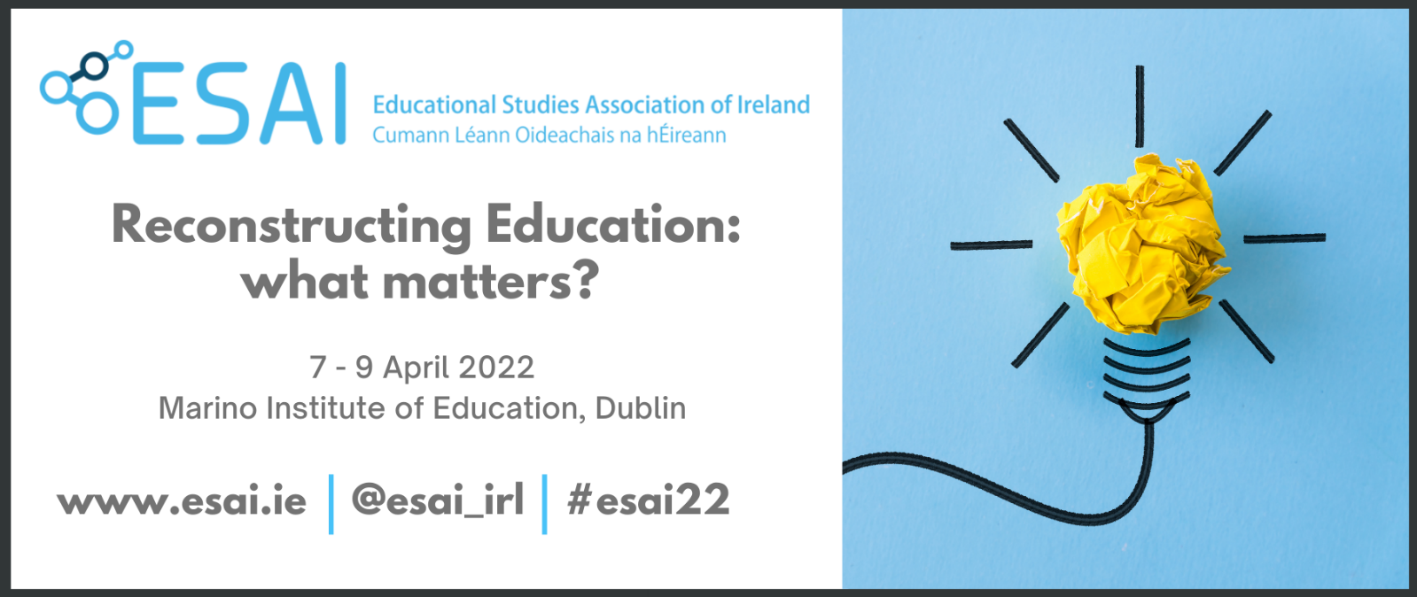

PROPOSAL TO OFFER A SYMPOSIUM

ESAI CONFERENCE 2022

Please complete this form and upload it to the online abstract submission system. The system will open on November 14, 2021 and will remain open until January 10, 2022.

Late Submissions will not be accepted.

Title of Symposium:
Corresponding Author:
Note: Author details, email addresses, affiliations and biographies should be submitted using the Abstract Submission system.

Abstract of Symposium
(400 words max)
Note: If possible, please use the ‘Abstract’ box of the online Abstract Submission system for this text.

Title of Paper 1 :
Author:
Abstract of Paper 1
(200 words max)

Title of Paper 2:
Author:
Abstract of Paper 2
(200 words max)

Title of Paper 3:
Author:
Abstract of Paper 3
(200 words max)

Title of Paper 4:
Author:
Abstract of Paper 4
(200 words max)

